**Linux Environment Variable Assignment**

1. State the command for the following.
   1. view current environment variables

* **printenv**

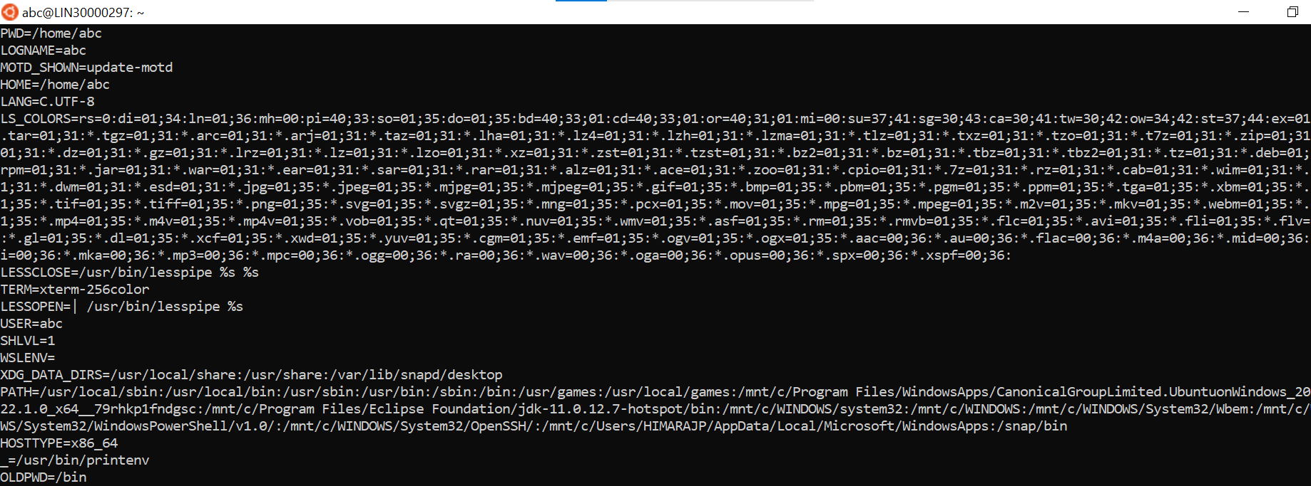

* 1. display the PATH environment variable value
* echo $PATH



* 1. update PATH to include the path to your home directory
* echo $PATH:home/abc



1. How will you make the environn1ent changes applicable to all users? Which script is to be 1modified?

* To declare the global variable in environment we have to declare var in “.bashrc”

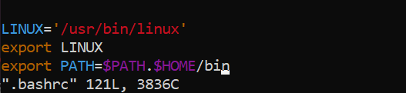

1. I have installed an application named “my app". After installation, if I invoke the application, it fails with error as "Command myapp not found". How will you fix this?
   * + To fix the error “Command myapp not found” in ubuntu, few steps can be used for resolving these errors:
       1. Making sure command is user’s path.
       2. Adding a new path to add new directory or the package “myapp”.
       3. Copying a file to existing path whenever the package is to be installed.